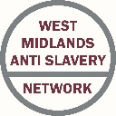

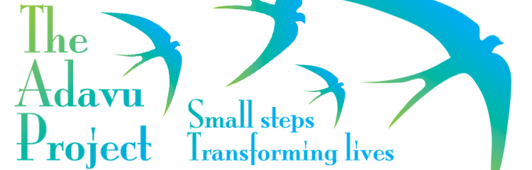 **Adavu**

Adavu is a project of the Birmingham Methodist District (charity no. 1134167) which aims to facilitate an effective local response to modern slavery. We were founded in 2011 initially to offer signposting support and training and awareness raising. Responding to the specific and complex needs of survivors, Adavu now also offers long term support to adult survivors of modern slavery and human trafficking making the transition into a life in the local community. We are based in Birmingham but take referrals from across the West Midlands for our after-care service.

Our Support Case Worker, Mohinder Kaur, offers frontline support to survivors, drawing on her qualified counselling skills and 15 years of experience in supporting survivors of modern slavery and domestic abuse.

Our Project Manager, Liisa Wiseman, has recently come into post. She brings with her over 15 years of managing community-led regeneration, running her own consultancy company and establishing and running one of the busiest foodbanks in the city where she directly supported survivors of modern slavery.

**For more information please contact Liisa on 07766 851838 or** [**wisemanl@adavu.org.uk**](mailto:wisemanl@adavu.org.uk)

**Twitter: @AdavuProject Facebook: AdavuProject** [**www.adavu.org.uk**](http://www.adavu.org.uk)

 **West Midlands Anti Slavery Network**

The Network has had a busy last quarter, together with partners, including planning an end to end table top exercise in September and a conference on the 18th October (Anti Slavery Day). Awareness of Modern Slavery is really being enhanced particular within the NHS, Health and Local Authorities. We see the table top exercise as having many outcomes including identifying the role of statutory and non-statutory agencies in victim care and support. We have had some excellent presentations too including: Office of the Independent Anti-Slavery Commissioner; West Midlands Modern Slavery Draft Strategy; WMP; Adavu; Modern Slavery Helpline; WMFS; and the Home Office Prevent Strategy. Please also keep an eye out for a forthcoming presentation and connections with our new partner The Co-Operative and their victim employment project Bright Futures. Excellent connections are being made between our partners and the external presenting partner agencies.

Thank you to all our partners for your continued support and achievements so far this year.

**Robin Brierley, Chair, West Midlands Anti Slavery Network**

August 2017

A network of agencies tackling modern slavery in the West Midlands and beyond

West Midlands Anti Slavery Network

[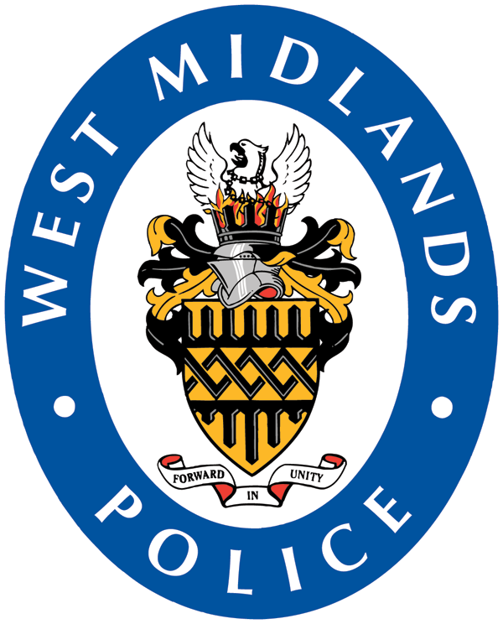](https://www.west-midlands.police.uk/) **West Midlands Police**

June saw the introduction of the newly formed West Midlands Slavery/Trafficking Strategic Partnership. The Partnership is chaired by Detective Superintendent Nick Walton, and was attended by Local Authority representatives, the PPTC, WMASN and other key stakeholders. The Group will report into PVVP (Preventing Violence Against Vulnerable People) in a manner similar to other areas of Vulnerability such as CSE, and will seek to identify and address strategic barriers to delivery. The Partnership will operate under the Liberate banner.

Meetings will take place on a quarterly basis and initial actions have been set to baseline the following:

- The capability of Local Authorities (L.A.’s) to mobilise a Reception Centre.

- The position regarding localised Slavery/Trafficking Groups within each of the 7 L.A.’s.

- Feedback as to the nature of information required to feed the said Groups, and

- A baseline of training delivered within the 7 L.A. areas.

Nick Walton said:

*“The first meeting was really encouraging, and I am grateful for the support of all the attendees. There is a real energy and appetite to drive this agenda forward and it was important that we develop a governance and accountability framework akin to other crimes of Vulnerability. This is the first stage of an evolving and exciting journey”.*

**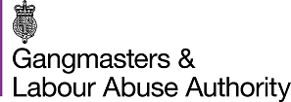 Tackling the scourge of modern slavery**

The Gangmasters and Labour Abuse Authority (GLAA) is the new national agency charged with protecting vulnerable workers in the UK from exploitation.

The GLAA has tough new powers and a broad remit to reflect greater focus upon exploitation in the workplace and, at its extreme level, trafficking and modern slavery.

This includes the use of improvement and enforcement notices to ensure vulnerable workers are prevented from being abused for their labour and also police-style powers of arrest under the Modern Slavery Act (forced or compulsory labour). This will seek to protect all workers, regardless of employment status.

To fulfil this remit, the GLAA has specialist investigators who will look into labour market offences - failure to pay National Minimum Wage (NMW) and breaches of the Employment Agency Standards Act, plus forced labour and human trafficking.

These changes are in direct response to the growing problem of labour exploitation and modern slavery across the UK where there are believed to be around 10-13,000 victims of slavery.

GLAA Chief Executive Paul Broadbent said: “Simple breaches of labour law creates the environment in which more extreme forms of abuse of workers can occur, leading to labour exploitation and forced or compulsory labour (modern slavery).”

It is estimated that organised crime groups are at the heart of much of this forced labour, which is worth tens of millions of pounds.

You can find out more about the role of the GLAA by visiting our [website](http://www.gla.gov.uk)and how to spot the signs of forced labour by clicking [here](http://www.gla.gov.uk/media/1573/human-trafficking-spotting-the-signs-v5-all-amends.pdf)**.**

**Gangmasters and Labour Abuse Authority (formerly the Gangmasters Licensing Authority)**

**DATE FOR YOUR DIARIES: WEST MIDLANDS ANTI SLAVERY NETWORK CONFERENCE ON ANTI-SLAVERY DAY, 18TH OCTOBER 2017, AT THE TALLY HO CONVENTION CENTRE, BIRMINGHAM. THIS YEAR THE FOCUS IS ON INDUSTRY AND LABOUR EXPLOITATION. MORE INFORMATION AND HOW TO REGISTER TO BE CIRCULATED SOON.**

**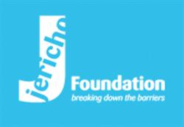**

**Jericho Foundation Welcomed at Downing Street for Celebrating Civil Society**

**in the Midlands Reception**

Richard Beard, Chief Executive, represented the Jericho Foundation at the ‘Celebrating Civil Society in the Midlands Reception’ on Wednesday 29th March. The event was held at No 10 Downing Street and was hosted by Rob Wilson MP, the Parliamentary Under Secretary of State for Civil Society, who was standing in for Theresa May. The reception was attended by a variety of charities, social enterprises and faith leaders delivering social impact in the West Midlands.

The Prime Minister has been vocal in her support of those with mental health issues and also the benefits of supported employment. The Jericho Foundation provides a wide range of support to people with mental health problems, including information, advice, guidance, personal development and training. Jericho also helps vulnerable individuals get back into a variety of roles such as supported employment, apprenticeships and volunteering opportunities in the organisation’s eight social enterprise businesses.

Richard said: *“We were delighted that Mr Wilson gave a special mention to the Jericho Foundation in his speech. We will continue with our mission to provide post-National Referral Mechanism support to the survivors of modern slavery. One thing which would assist these brave people would be the confirmation of conclusive grounds guaranteeing benefits eligibility.”*

#birmingham #charity #socent #humantrafficking #modernslavery #westmids #buysocial #no10 #supportedemployment

If you would like more information, please email or call the Jericho Foundation:

**Email:** [enquiries@jericho.org.uk](mailto:enquiries@jericho.org.uk) **Tel: 0121 647 1960**

**West Midlands Anti Slavery Network Meeting Dates**

WMASN meeting dates for 2017, for further information including venue contact [donna.pryor@westmidlandsantislavery.org](mailto:donna.pryor@westmidlandsantislavery.org)

**14th September 2017**

**16th November 2017**

[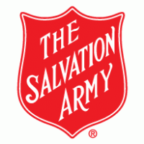](https://www.salvationarmy.org.uk/)**Salvation Army Adult Victim of Modern Slavery Care and Coordination Services**

**General Enquiries:**

**0300 303 0547 / 0548**

**Mon to Fri - 09:00 to 17:00**

**24 hour new referral and out of hours line:**

**0300 303 8151**

**USEFUL LINKS**

**Modern Slavery Helpline – 08000 121 700**

**NRM:** <https://www.gov.uk/government/publications/human-trafficking-victims-referral-and-assessment-forms>

**Force Intelligence Bureau (FIB)**

[fib@west-midlands.pnn.police.uk](mailto:fib@west-midlands.pnn.police.uk)

**Modern Slavery Act Duty to Notify:**

<https://www.gov.uk/government/publications/duty-to-notify-the-home-office-of-potential-victims-of-modern-slavery>

**Human Trafficking Foundation Trafficking Survivor Care Standards**

[http://www.humantraffickingfoundation.org/sites/default/files/Trafficking%20Survivor%20Care%20Standards%202015.pdf](http://www.humantraffickingfoundation.org/sites/default/files/Trafficking%20Survivor%20Care%20Standards%202015.pdf" \t "_blank)

**WMASN contacts**

**Robin Brierley**

**Chair; West Midlands Anti Slavery Network.**

Direct: [+44(0)1686 669911](tel:%2B44%280%291686%20669911) | Mobile [+44 (0) 7412 482791](tel:%2B44%20%280%29%207412%20482791)

Email: [info@westmidlandsantislavery.org](mailto:info@westmidlandsantislavery.org)

**Donna Pryor**

**Network Support; West Midlands Anti Slavery Network.**

Email: [donna.pryor@westmidlandsantislavery.org](mailto:donna.pryor@westmidlandsantislavery.org)

**Abby Scott**

**Network Support (Social Media); West Midlands Anti Slavery Network**

Email: [abby.scott@westmidlandsantislavery.org](mailto:abby.scott@westmidlandsantislavery.org)

[www.westmidlandsantislavery.org](http://www.westmidlandsantislavery.org/)

[](https://www.facebook.com/WMASN/)[](https://twitter.com/WestMidsASN)





