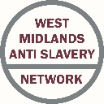

Meeting Dates

WMASN meeting dates for 2017, for further information including venue please contact [donna.pryor@westmidlandsantislavery.org](mailto:donna.pryor@westmidlandsantislavery.org)

**26th January 2017**

**9th March 2017**

**20th April 2017**

**1st June 2017**

**13th July 2017**

**24th August 2017**

**5th October 2017**

**16th November 2017**

December 2016

WMASN Subgroup Leads

Training

**Gary Booth – Hope for Justice:** [**gary.booth@hopeforjustice.org**](mailto:gary.booth@hopeforjustice.org)

Intelligence

**T.B.C.**

Partnerships

**Shelley Ward – PVVP:**

[**shward@solihull.gov.uk**](mailto:shward@solihull.gov.uk)

West Midlands Anti-Slavery Day Conference – The Victim’s Journey

On 18th October 2016 – Anti-Slavery Day – ‘The Victim’s Journey’ conference was held at Tally Ho in Birmingham.

The concept originated from an idea by Robin Brierley of the West Midlands Anti Slavery Network (WMASN) and the PCC Victims Commission. It was important to commemorate Anti-Slavery Day in an appropriate way, and at the same time raise awareness of Modern Slavery and in particular aim the conference at agencies who were in a position to identify victims and would benefit from the knowledge of experts in the field of Modern Slavery. Over 250 people attended on the day representing a wide range of agencies from the DWP to the NHS to WMFS and many more.

During a day of many highlights 11 different speakers talked about modern slavery from the perspective of the victim in relation to their agency including Black Country Women’s Aid who focused on challenges facing the victim and Barnardo’s with regard to child trafficking and the Panel for the Protection of Trafficked Children. For part of the day delegates worked in groups to identify the challenges to organisations based on the WMASN subgroups of partnership working, training and information sharing. The data that arose from this exercise will be analysed and used to evidence the need to raise awareness, share information and work in partnership. We also hope that agencies will share information from the day with others who would benefit in the West Midlands and further afield.

Feedback was excellent with many complimentary emails and calls and agencies seeking to do more with regard to training and information sharing. We seek to build on this success as we move forward in to 2017 and look toward the conference next year.

A network of agencies tackling modern slavery in the West Midlands and beyond

West Midlands Anti Slavery Network

CRIMESTOPPERS FILLS THE INTELLIGENCE GAPS IN HUMAN TRAFFICKING

Crimestoppers charity helps to solve crimes by encouraging information from those who know the criminals. So, anyone who knows those in the Human Trafficking trades can tell the charity, safe in the belief that they cannot be identified.

The national charity is the only agency these people can turn to for guaranteed anonymity. They can even pick up a cash reward for their trouble, which is paid out in a way that continues to assure that their identity is not revealed.

Pauline Hadley, West Midlands Regional Manager said: “We work with partners across county borders to safeguard victims and bring traffickers to justice. Crimestoppers is another vital tool in the your toolkit..

“Those who know the traffickers often feel vulnerable and afraid. They don’t know who to trust and they feel they cannot report what they see to the authorities.

“A recent survey has revealed that Crimestoppers is engaging with more than double the proportion of people from ethnic communities than are represented in the general public. They tell us that the guarantee of anonymity is the main reason they contact us and that being a charity shows that we are trustworthy and that we genuinely care.”

**0800 555 111** [www.crimestoppers-uk.org](http://www.crimestoppers-uk.org)



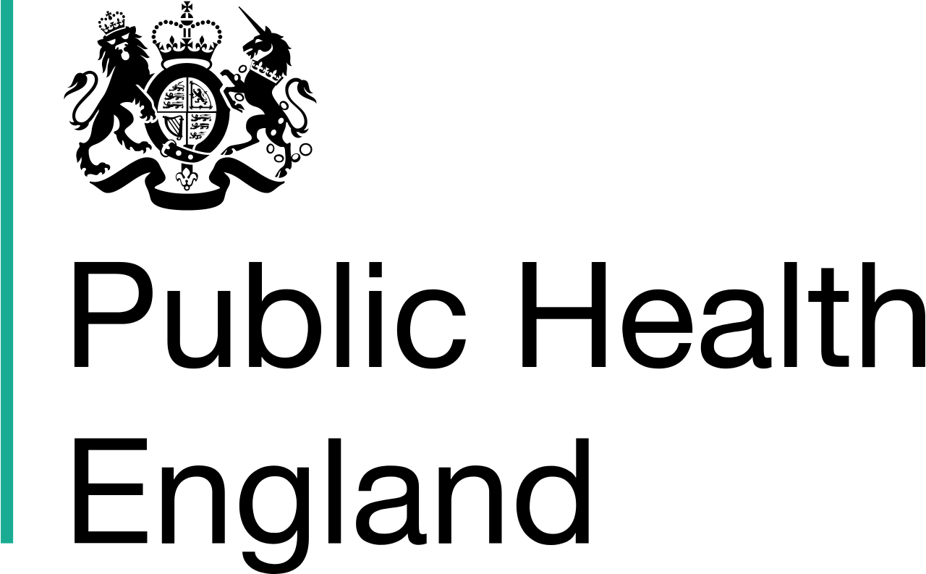

Fighting Modern Slavery in the West Midlands

On 15 November, PHE West Midlands hosted a stakeholder event to bring partners from across the region together to address the important topic of modern slavery. This is such a difficult subject to tackle, as it is often an ‘invisible crime’, with exploitation taking many forms, from labourers paid a pittance and forced to live in inhumane conditions, to women trafficked to become sex workers, and even the horrific truth of children trafficked for organ harvesting. With 13,000 victims of modern slavery in the UK, and one in three people trafficked being children, it is vital to join together to spot the signs, share information, and protect as many vulnerable people as we can. People targeted have social and health inequalities, such as living in poverty, those with learning difficulties and mental health issues, addictions, and vulnerable children and young people. Life in slavery only makes their health and wellbeing worse, so PHE has an active part to play.

Health and Wellbeing Manager Karen Saunders spearheaded the event for PHE West Midlands, with key partners and speakers from the West Midlands Anti Slavery Network, West Midlands Police, West Midlands Fire Service and Barnardo’s.

The event was a huge success and anyone interested can talk to Karen and go to the @PHE_WestMids Twitter account, where a ‘Twitter moment’ captures some of the content and thoughts from delegates. The event served to galvanise partners across the region to be ever-vigilant and really ‘Make Every Contact Count’; work closely with stakeholders across the region to embed knowledge sharing and really fight this terrible crime on the frontline.

**HAPPY CHRISTMAS TO ALL OF OUR MEMBERS AND WE LOOK FORWARD TO CONTINUING OUR PARTNERSHIPS IN 2017!**

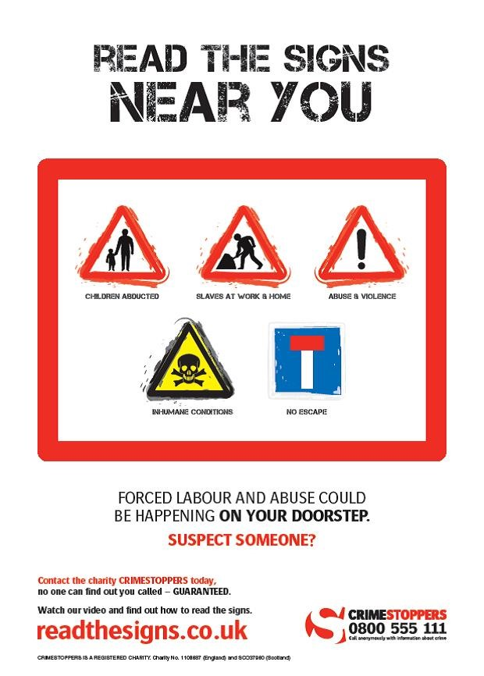

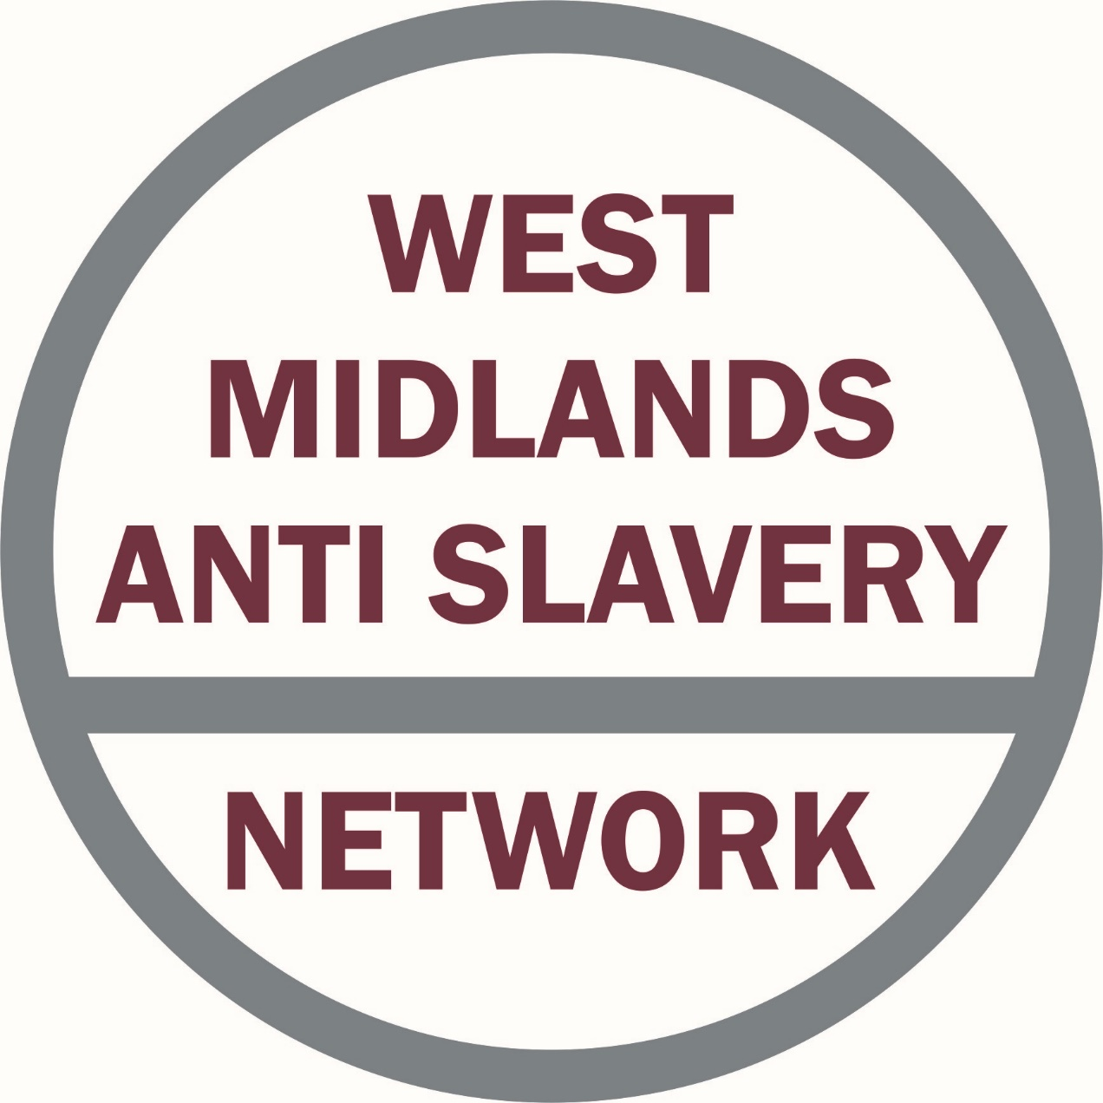

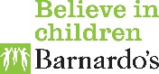

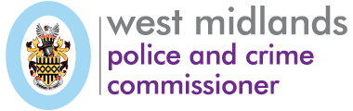

Useful Links

NRM - <https://www.gov.uk/government/publications/human-trafficking-victims-referral-and-assessment-forms>

Force Intelligence Bureau (FIB) – [fib@west-midlands.pnn.police.uk](mailto:fib@west-midlands.pnn.police.uk)

Modern Slavery Act Duty to Notify - <https://www.gov.uk/government/publications/duty-to-notify-the-home-office-of-potential-victims-of-modern-slavery>

WMASN contacts

**Robin Brierley**

**Chair; West Midlands Anti Slavery Network.**

Direct: [+44(0)1686 669911](tel:%2B44%280%291686%20669911) | Mobile [+44 (0) 7412 482791](tel:%2B44%20%280%29%207412%20482791)

Email: [info@westmidlandsantislavery.org](mailto:info@westmidlandsantislavery.org)

**Donna Pryor**

**Network Support; West Midlands Anti Slavery Network.**

Email: [donna.pryor@westmidlandsantislavery.org](mailto:donna.pryor@westmidlandsantislavery.org)

[www.westmidlandsantislavery.org](http://www.westmidlandsantislavery.org/)

[](https://www.facebook.com/WMASN/)[](https://twitter.com/WestMidsASN)